

AMMAN ARAB UNIVERSITY
جامعة عمان العربـيــــــة
Faculty of IT
كلية تكنولوجيا المعلومات

FixIt Jo

Students:
Amneh Alhemony | 202120371
Tuleen Alshhattel | 202210551

Supervisor:
Dr. Alaa Abuthawabeh

Amman – Jordan
2025/2026

Table of Contents
Chapter One
INTRODUCTION 1
1.1 Problem Statement 1
1.2 Business case 1
1.3 Aim and Objectives 1
1.4 Project Scope 2

Chapter Two
Project Planning and Requirements 3
2.1 Project Plan and Schedule 3
2.1.1 Gantt Chart 3
2.2 Functional Requirements 4
2.3 Non-Functional Requirements 4
2.4 Software Development Methodology (SDLC Model) 5

Chapter Three
SYSTEM ANALYSIS AND DESIGN 6
3.1 System Architecture 6
3.2 Use Case Diagram 7
3.3 Relational Schema 8
3.4 ER Diagram 8
3.5 Class Diagram 9
3.6 UI Mockups 10

Chapter One

Introduction

Problem Statement
Most of citizens in Jordan face significant challenges in finding qualified, reliable, and available technicians when maintenance services are needed. There is no unified digital platform that guarantees service quality, enables comparing technicians, viewing previous work, checking availability, or tracking the status of requests. This lack of structure leads to delays, miscommunication, and difficulty in making informed decisions.

On the other hand, many skilled technicians struggle to reach customers due to the absence of an organized system that allows them to showcase their expertise, receive service requests, and build a professional reputation through transparent ratings and reviews. As a result, both customers and technicians suffer from limited visibility, wasted time, and reduced trust.

Therefore, there is a clear need for a centralized mobile application in Amman that connects customers and technicians efficiently. Such a system would organize services, improve accessibility, ensure transparency, and provide a reliable and professional method for requesting and delivering home maintenance services.

1.2 Business Case
The FixIt Jo application is designed to solve the problem of difficulty in finding reliable maintenance technicians in Jordan. Many customers struggle to locate skilled technicians quickly, while technicians face challenges in reaching potential clients.
The proposed solution is a mobile application that connects customers with technicians in an easy and efficient way. Customers can request services such as plumbing, electrical work, or home maintenance, while technicians can receive job requests based on their skills and location.
This system will improve service accessibility, reduce time and effort for both customers and technicians, and enhance trust through ratings and reviews. Additionally, it will support local technicians by providing them with more job opportunities.
Overall, FixIt Jo aims to simplify the maintenance service process and create a convenient platform for both service providers and customers.

Aim and Objectives
The main objective of this project is to develop an effective mobile application that connects customers with local technicians for home maintenance services in Amman. The specific objectives are:
- To investigate user needs and the challenges faced in accessing home maintenance services.
- To provide a reliable and unified digital platform that facilitates communication between customers and technicians.
- To develop a user-friendly mobile application that integrates GPS-based services and an AI chatbot
To evaluate the system’s functionality and usability to ensure it meets user requirements

1.4 Project Scope

The project involves developing a mobile application that connects customers with skilled workers in Amman. Users can request services such as plumbing, electrical maintenance, carpentry, and other technical work through categorized options and interact using a built-in chatbot. Workers can register, create profiles, and manage job requests efficiently.
In-Scope:
- Mobile applications for customers and service providers
- Registration & login for both user types
- Categorized service selection
- Location-based requests (within Amman)
- Basic chatbot support
- Service requests & notifications
- Worker profiles (skills, availability, pricing)
- Customer ratings and feedback
Out-of-Scope:
- Online payment and billing integration.
- Advanced AI-based recommendations and predictive analytics.
- Provision of services outside the geographical region of Amman.
- Web-based platform development (the current implementation is mobile application only).
- Integration with governmental services or business licensing systems.

Chapter Two

Project Planning and Requirements

2.1 Project Plan and Schedule
The planning phase of the FixIt Jo project focuses on organizing the development process and defining the steps required to build the application successfully.
First, the system requirements are identified, including user registration, service booking, technician management, and rating features. Then, the project tasks are divided into stages such as design, development, testing, and deployment.
A timeline is created to ensure that each phase is completed on time. The project also assigns responsibilities, where developers focus on coding, designers handle the user interface, and testers ensure system quality.
Tools such as Flutter will be used for application development, and a database system will be implemented to manage users and bookings.
Overall, proper planning ensures that the project is completed efficiently, within time, and meets user needs.

Table 2.1 FixIt Jo Gantt Chart
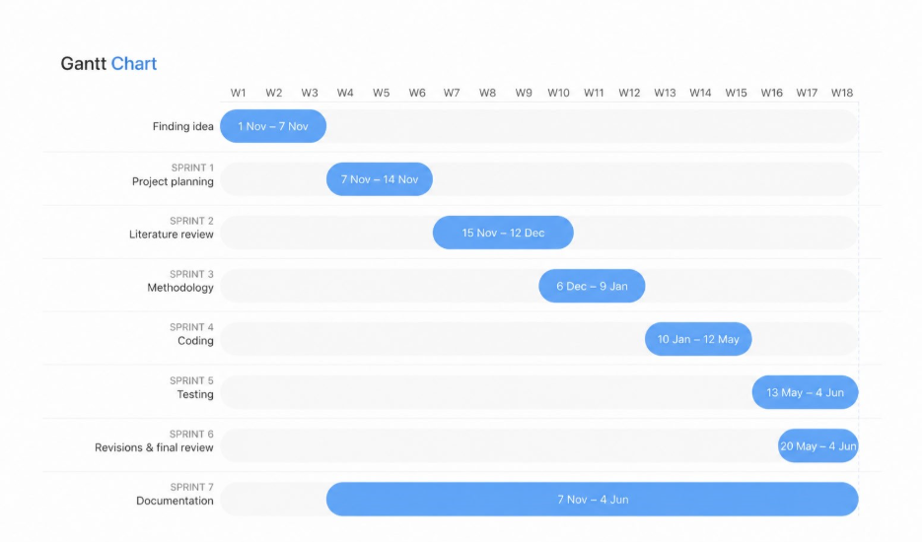

2.2 Functional Requirements

FR1 The system allow users and technicians to create accounts and login.

FR2 The system shall enable users to request maintenance services by category.

FR3 The system shall display nearby available technicians using GPS.

FR4 The system shall support in-app communication between users and technicians.

FR5 The system allow users to upload photos to explain their issues.

FR6 The system shall provide chatbot assistance to help users select the appropriate service.

FR7 The system shall enable technicians to manage their profiles and availability.

FR8 The system shall allow users to rate and review technicians after service completion.

2.3 Non-Functional Requirements
NF1 Performance: The system shall respond to user requests within an acceptable time and efficiently handle multiple users.
NF2 Security: User data and communication shall be protected using secure authentication and data protection mechanisms.
NF3 Usability: The application shall have a simple and user-friendly interface suitable for users with different technical backgrounds.
NF4 Reliability: The system shall provide accurate GPS matching and ensure service availability information is up to date.
NF5 Scalability: The system shall support future expansion to additional cities and increased numbers of users.
NF6 Availability: The application shall always be accessible except during scheduled maintenance.

2.4 Software Development Methodology (SDLC Model)

For the development of the FixIt Jo application, the Agile Scrum SDLC model will be followed.
This model is well-suited for the project because it supports iterative development, continuous
feedback, and flexibility in handling changing requirements.
The use of this model provides several advantages:
- Step-by-step development of system features, ensuring better control over the project.
- Flexibility to modify requirements based on user feedback during development.
- Continuous testing after each sprint to ensure system reliability and performance.
- Improved collaboration among team members through regular updates and reviews.

Each sprint follows a structured process that includes planning, design, development, testing, and
review. During the planning phase, the required features are identified and prioritized. In the
design phase, system structure and user interface are prepared. The development phase involves
coding the features, followed by testing to ensure correctness. Finally, feedback is collected and
improvements are applied in the next sprint.

This iterative approach reduces project risks, improves system quality, and ensures that the final
application meets user needs effectively. It also supports future scalability and enhancements,
making the system more maintainable and adaptable.

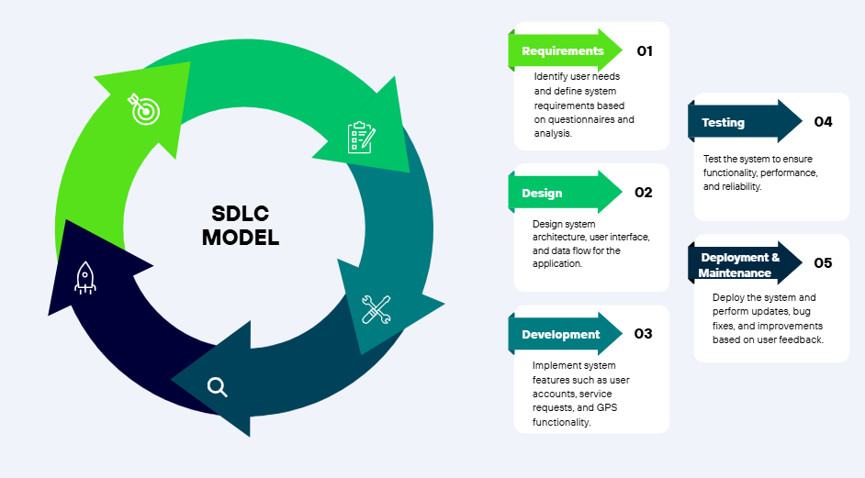
Figure 2.2 Incremental SDLC Model

Chapter Three

System Analysis and Design

3.1 System Architecture
FixIt Jo follows a client–server architecture. The Flutter mobile application acts as
the client layer, where customers, technicians, and admin interact with the system.
Firebase services act as the backend layer, providing authentication, cloud database management, storage, and real-time updates. This architecture allows the application to separate the user interface from data processing and storage, improving maintainability, scalability, and synchronization between users.
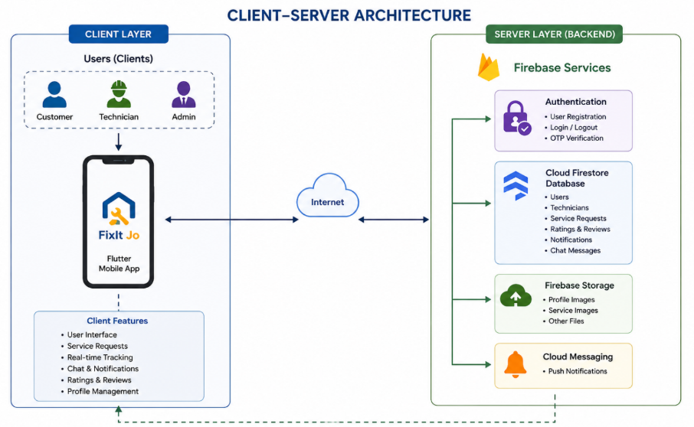

Figure 3.1 Client- Server System Architecture

3.2 Use Case Diagram
Figure 3.2 shows a Use Case Diagram of the FixIt Jo application. It illustrates the system’s functionality from the perspective of its main users, including the Customer, Technician, and Admin.

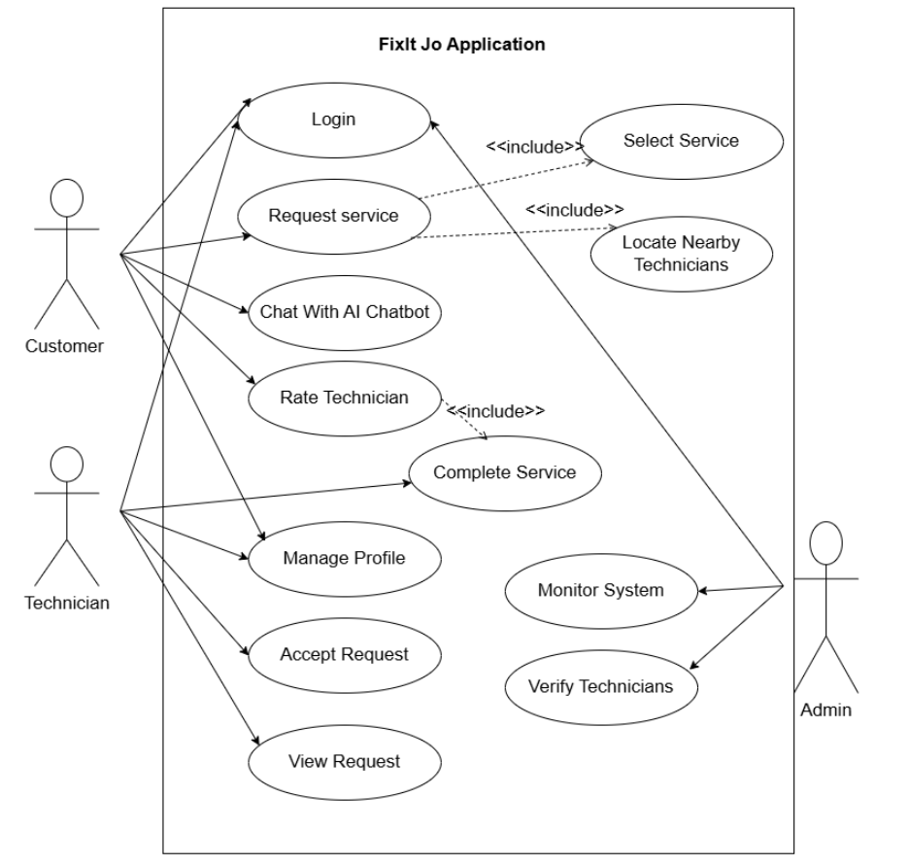
Figure 3.2 Use Case Diagram

3.3 Relational Schema
Figure 3.3 illustrates the relational schema of the FixIt Jo system. The database consists of three main tables: Users, ServiceRequests, and Reviews. The Users table stores basic information about customers and technicians. The ServiceRequests table records service requests created by users and optionally assigned to technicians, while the Reviews table stores feedback and ratings provided after completing services. The schema defines primary and foreign key relationships between the tables to ensure data integrity and to support the main functionality of the system, where each user can create multiple service requests and submit reviews.

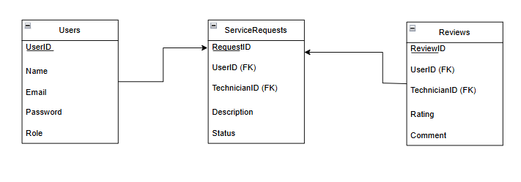

Figure 3.3 Relational Schema

3.4 ER Diagram
Figure 3.4 shows an Entity-Relationship Diagram (ERD) of the FixIt Jo application. It represents the database structure and the relationships between the main entities in the system, including Users, Service Requests, Technicians, and Ratings. The diagram illustrates how each user can create multiple service requests, and how technicians can be assigned to handle these requests. It also shows that users can provide ratings for technicians after completing services. The ERD ensures clear data organization and maintains relationships through primary and foreign keys to support data integrity and efficient system operations.

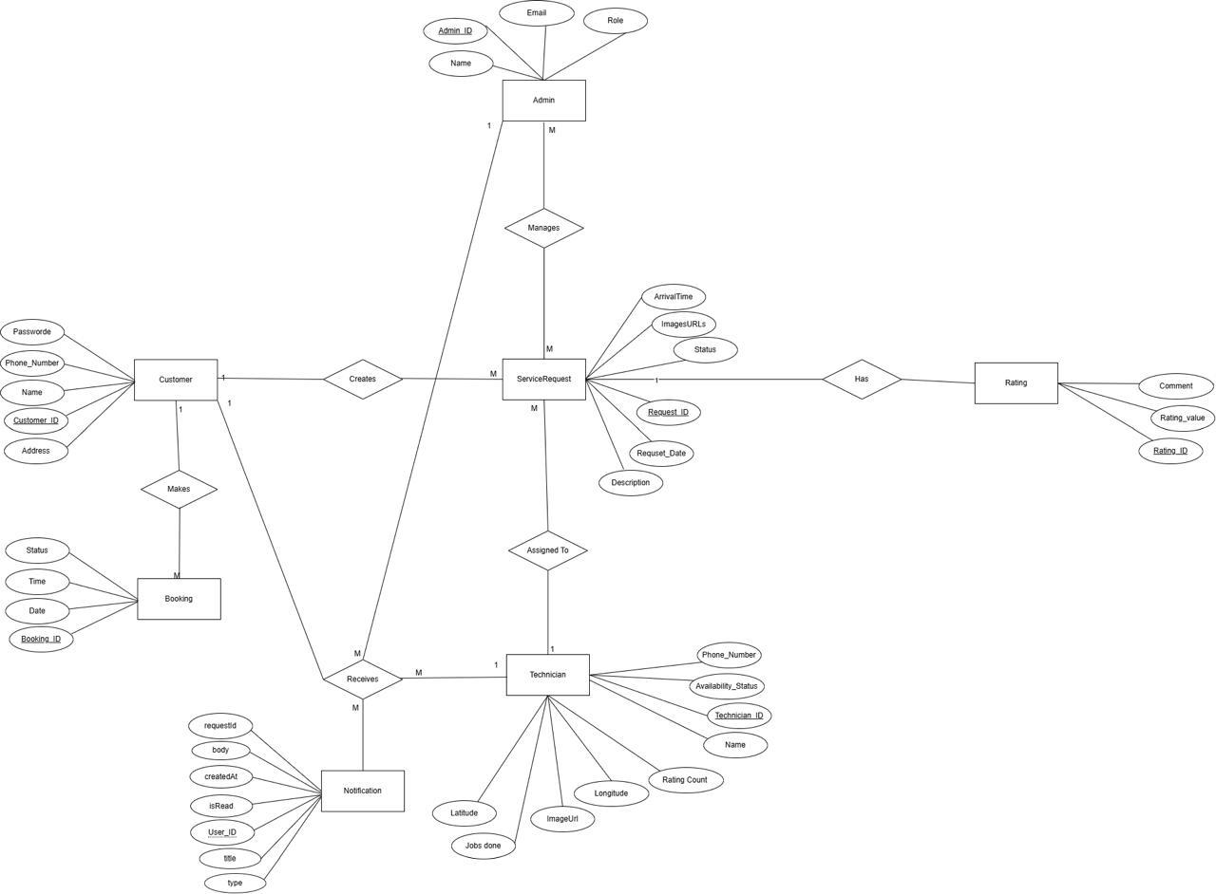
Figure 3.4 ER Diagram

3.5 Class Diagram
Figure 3.5 shows a Class Diagram of the FixIt Jo application. It represents the system’s structure in terms of its main classes, including User, ServiceRequest, Technician, and Rating. The diagram illustrates the attributes and methods of each class and how they interact with each other. It also shows the relationships between classes such as inheritance, association, and dependency, which help define the system’s logic and behavior. The Class Diagram provides a clear overview of the system’s object-oriented design and supports better understanding of how the application is implemented.
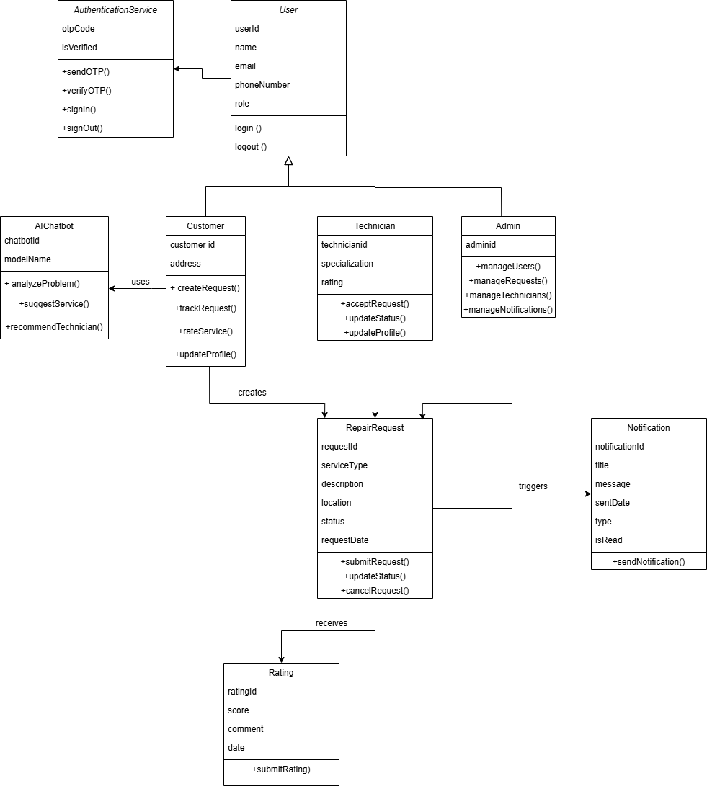

Figure 3.5 Class Diagram

3.6 User Interface Mockups
The following figures present the User Interface (UI) mockups designed for the FixIt Jo
mobile application. The UI follows a clean and modern design with light blue and white
color scheme, ensuring a simple and user-friendly experience for all users.
Figure 3.6.1 illustrates the Login Screen of the FixIt Jo application it allows users to log in using their
Jordanian mobile number (+962) to access the system.

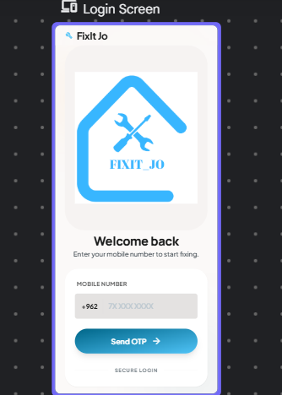

Figure 3.6.1 Login Screen (OTP-Based Authentication)

Figure 3.6.2 displays the Registration Screen of the FixIt Jo application. It allows new users to create
an account by first selecting their role as either a customer or a technician using interactive
selection cards at the top of the screen.
When the user selects the Technician role, additional fields appear below, allowing the technician
to enter their full name, phone number with the Jordanian country code (+962), and select their
specialization from a grid of options including Plumbing, Electrical, Carpentry, and AC Repair.
The specialization section supports multiple selections, enabling technicians to offer more than
one service type.
A Register button is placed at the bottom of the screen, along with a link to the Login screen for
users who already have an account.
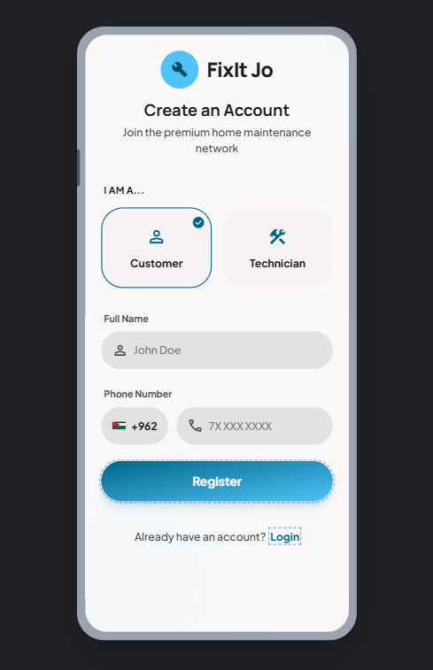

Figure 3.6.2 Customer Register Screen
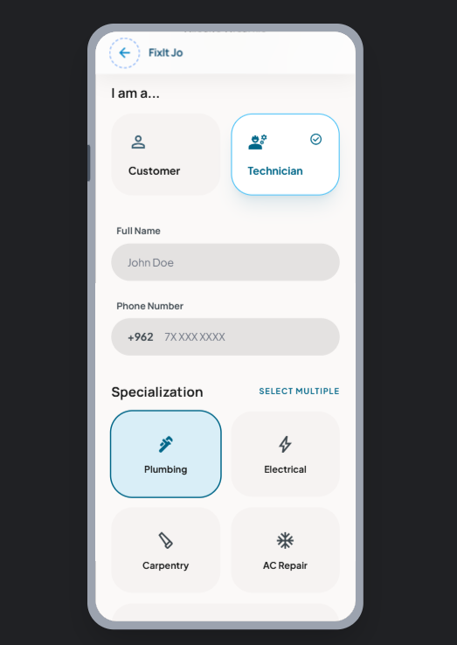
Figure 3.6.3: Technician Register Screen

Figure 3.6.4 shows the Customer Home Screen, which is the main dashboard accessible after
login. The screen greets the user by name at the top with a notification bell icon. A promotional
banner reads "Need a fix? We've got the pros for you." Below the banner, a search bar allows
customers to search for services directly. The screen features a Categories section displaying
service types in a grid layout, including Plumbing, Electrical, Carpentry, and AC Repair, each represented with an icon. A bottom navigation bar provides quick access to Home, Request, Map,
Chat and Profile sections.
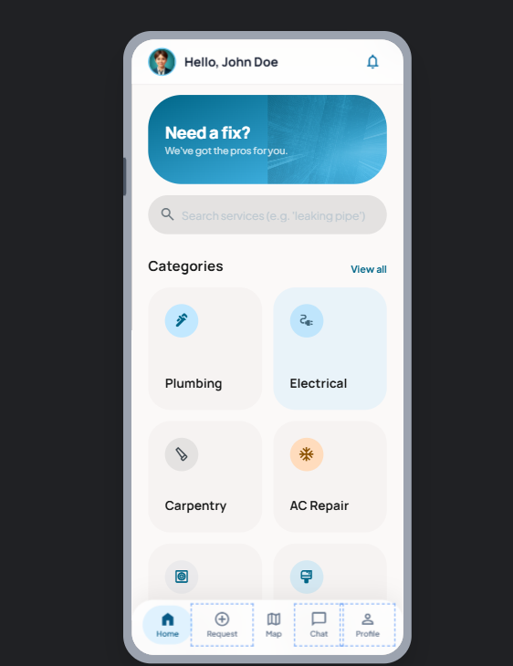
Figure 3.6.4 Customer Home Screen

Figure 3.6.5 illustrates the Technician Home Screen, which provides an overview of the
technician's performance and incoming service requests. The screen displays key statistics
including Earnings, Jobs Done, Rating, and Efficiency in a card-based layout. Below the
statistics, an Incoming Requests section shows a map preview with a request pin and details of
the customer's request, including the customer’s name, service type, location, and expected time.
The technician can Accept or Decline the request directly from this screen. A bottom navigation
bar provides access to Home, Requests, Map, and Profile sections.

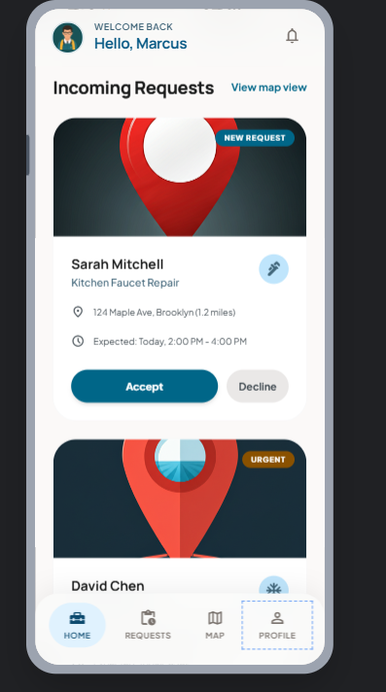

Figure 3.6.5 Technician Home Screen

